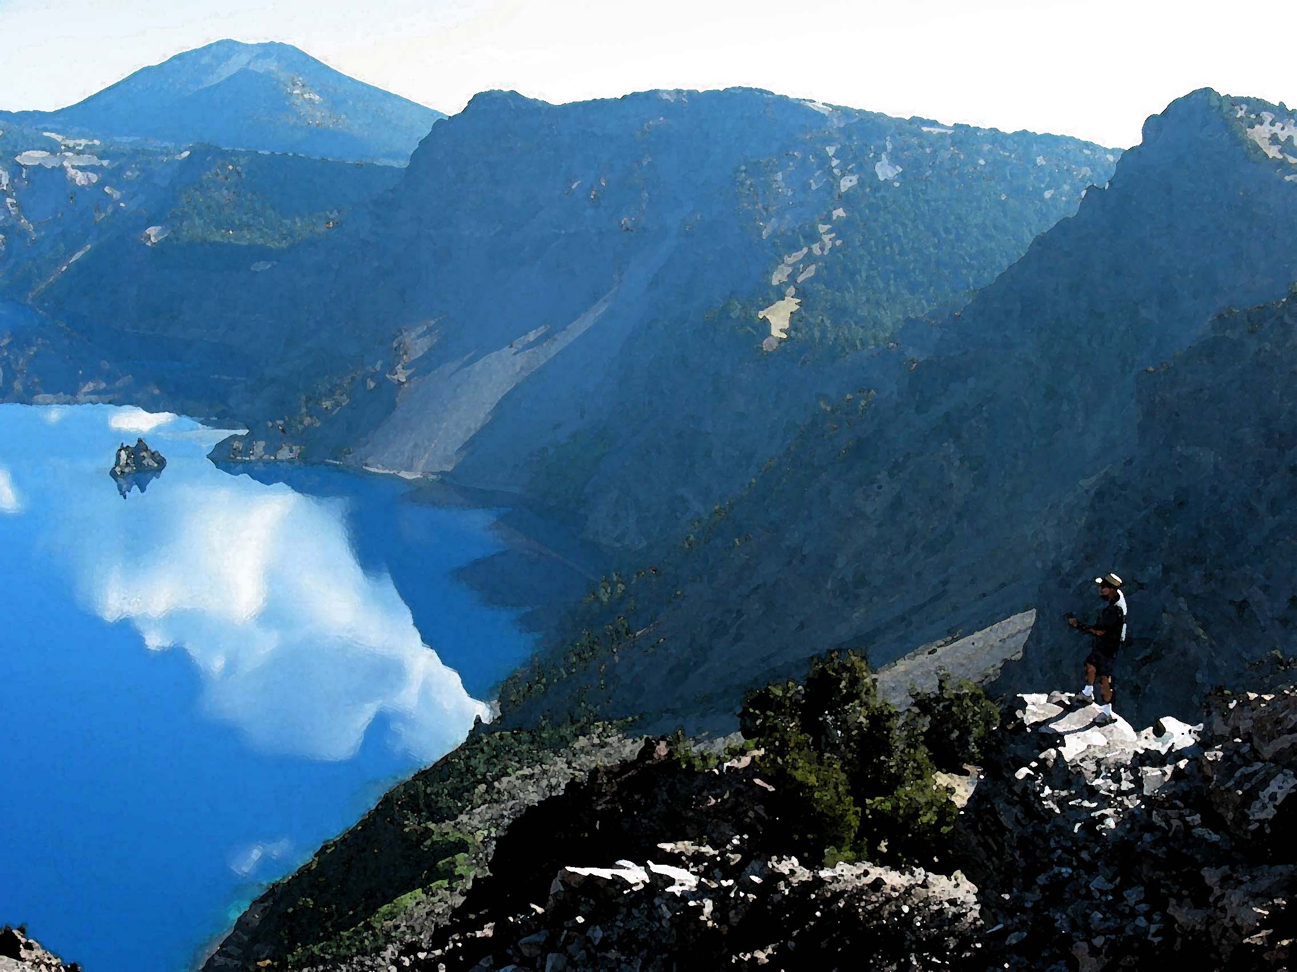  Crater Lake  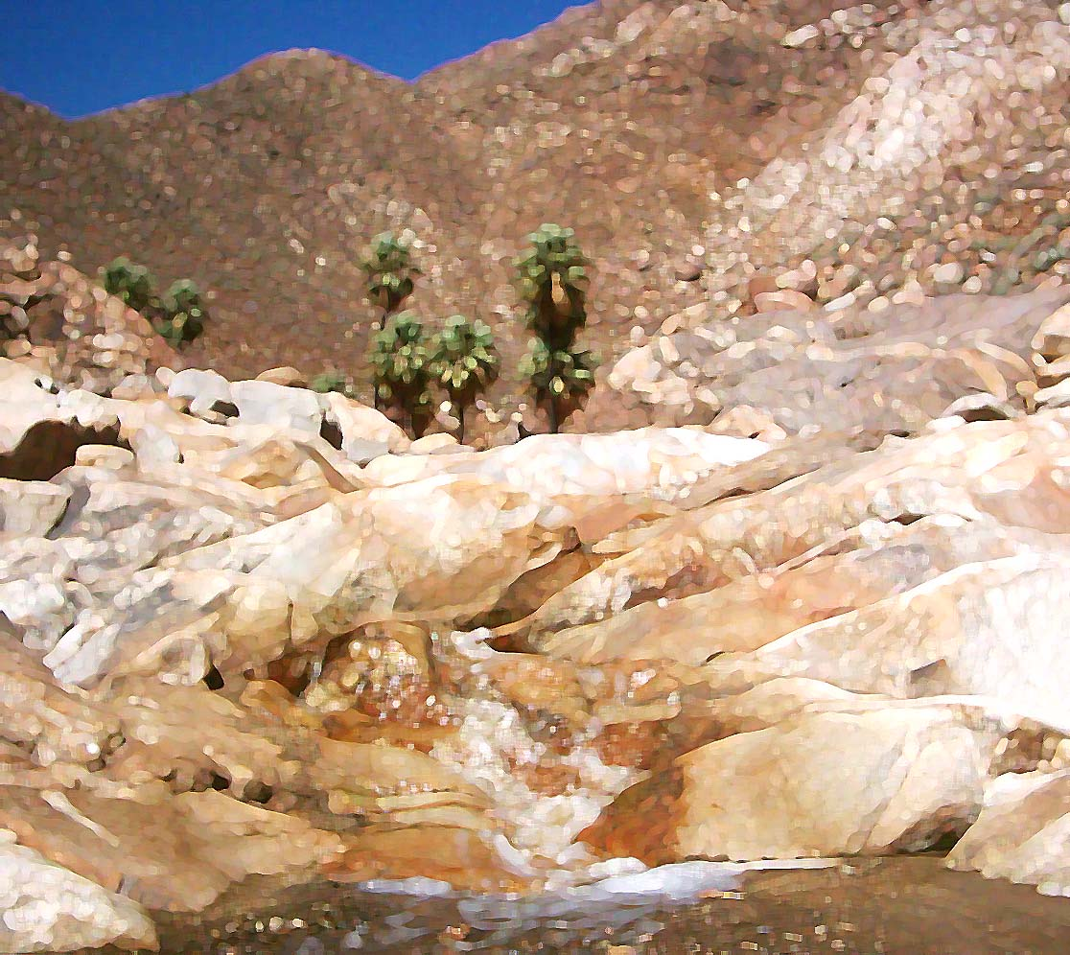  Upper Palm Canyon | 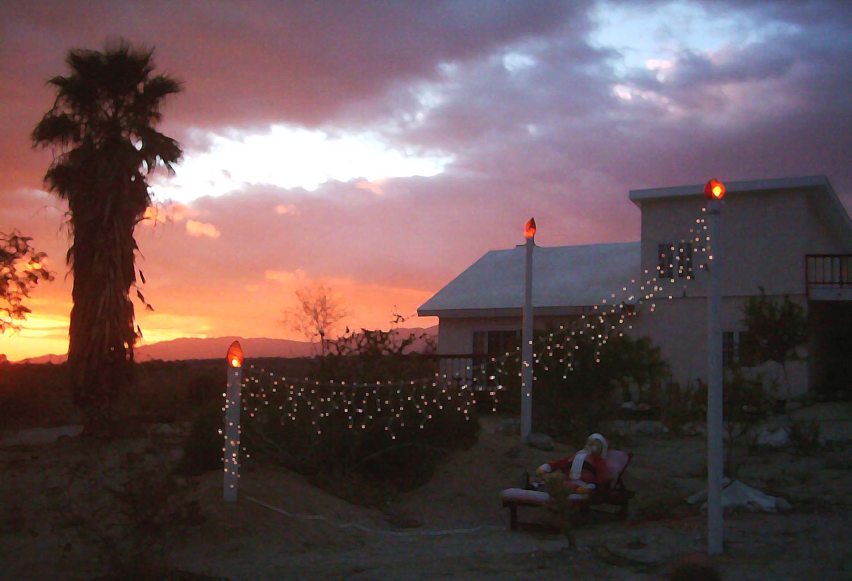

Hi,  Had another busy year:  - Did a bunch of handy-man-type jobs. Started with 1 client, and ended up with about 10! Projects included fencing, carpentry, tiling, roof-repair, landscaping, etc. Designed addition to former Borrego Crick house, which was later built. Nobel laureate, Francis Crick, passed away this past summer.  - Went on some great hikes. Did the maps for Robin’s hiking book, coming out soon.  - Mom had cataracts taken care of. Long-time friend, Craig, got married again, this very month.  - Took neighbor Olga to San Diego a number of times, but she passed away late in the year, and Dick moved to Arizona.  - Got hot tub working again after 2+ years!  - Nissan got damaged by crashing into a rock and dirt bank, but was fixed at same time Mazda was being diagnosed, so was sans car for about 10 days.  - Attended 2 eventful cannon parties.  - Toured north-eastern California and south-eastern Oregon for about a week with Arizonan compadre, hitting Crater Lake, Lava Beds, and Mt. Lassen.  Anyway, did lots of other stuff, which, if you were interested, is in my journal at  http://jef.itforsb.net/jef/2004/act.html  Hope you have an enjoyable holiday season and a great 2005! BTW: my hot tub is online  Love, Jef | 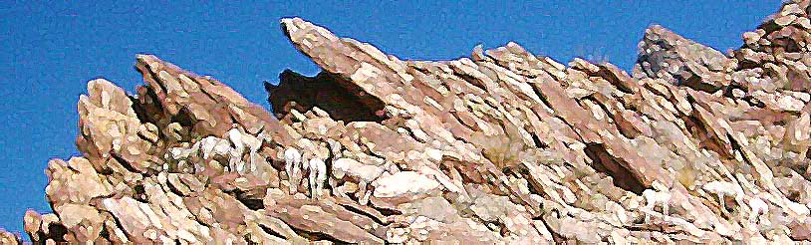  Bighorn sheep on ridge beside Palm Canyon, September 2004  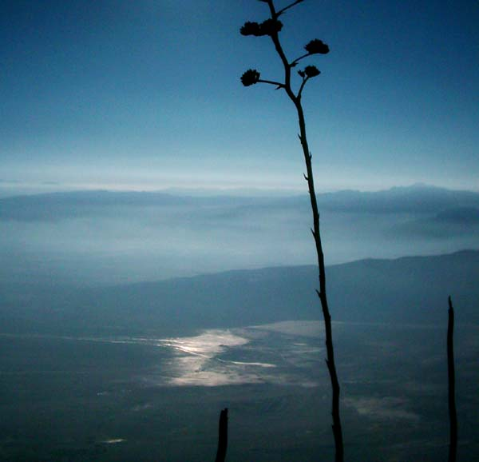  Mud glistens on southern edge of Clark Lake from Villager Ridge, December 9, 2004

